**How to run the computer models**

It can be fun to play around with the models of evolution introduced in class. The models used in Lecture 4 are written in a programming language called Python, but you don’t need to know any programming in order to run them.

To play around with these models, you will need to use a software called Anaconda. You can easily download Anaconda for free at <https://www.anaconda.com/products/individual>. Anaconda installs several applications on your computer, but to read the models you just need to launch the one called “Jupyter Notebooks”. After launching Jupyter, you should see a page like the following one appear on your web browser:

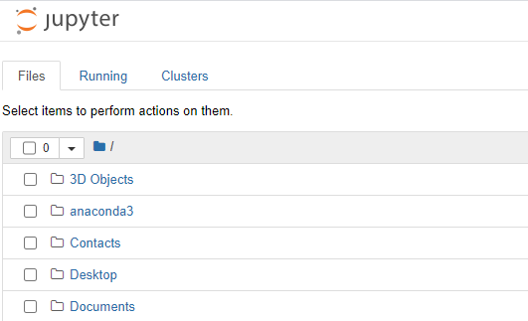

This is simply the list of folders on your computer. In order to run a model, simply download the file for that model in your favorite folder, and then open it with Jupyter.

Then you should see something that looks like this:

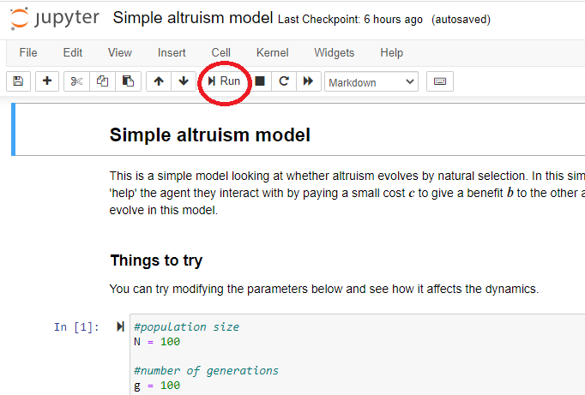

This is a ‘notebook’: a mix of code (meant to be ‘read’ by the computer) and of words in English (meant to be read by a human user). I have written a few lines at the start of each notebook to recap how the model works. To run the model, simply click on the “Run” button (circled in red on the picture above). If you then scroll down to the end you will see a graph of the evolutionary dynamics.

Try running the same model several times to see if a particular outcome is robust or due to chance!

**Modifying parameters.** A fun aspect of modeling is the ability to play around with the parameters of the simulation, to see the impact they have on the resulting dynamics. It is easy to look under the hood of a model and change the parameters. To do so, just look at the box of code that is just underneath the mention “Things to try”, where I have collected all the parameters that are potentially interesting to modify.

You can change the parameters simply by entering a new value for the parameter that you want. Then, run the model again by clicking on the two arrows circled in red in the picture below, and selecting ‘restart and run all cells’ to see what impact your change has made!

